ARTICLE ON ONLINE FRAUD

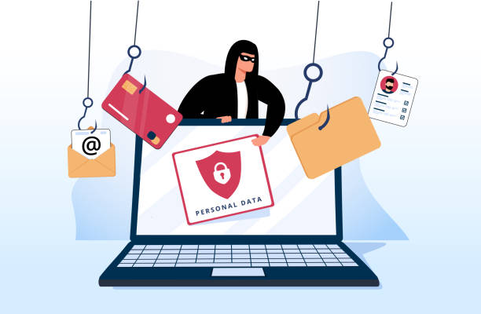

In the age of information technology, online fraud has become a prevalent issue in the digital age, impacting individuals, businesses & financial institutions worldwide. As it poses a significant threat in today’s digital landscape, by understanding the scope of the problem, recognizing its various forms and taking preventive measures, we can mitigate its impact and protect ourselves against financial loss and personal harm.

What is Online Fraud?

Online fraud refers to any fraudulent activity or deception conducted over the internet with the intent of obtaining financial gain or stealing personal information. The prepetrators often use deceptive tactics to trick individuals into providing sensitive information or making payments, leading to financial losses, identity theft & other harmful consequences for the victims.

Types of Online Frauds

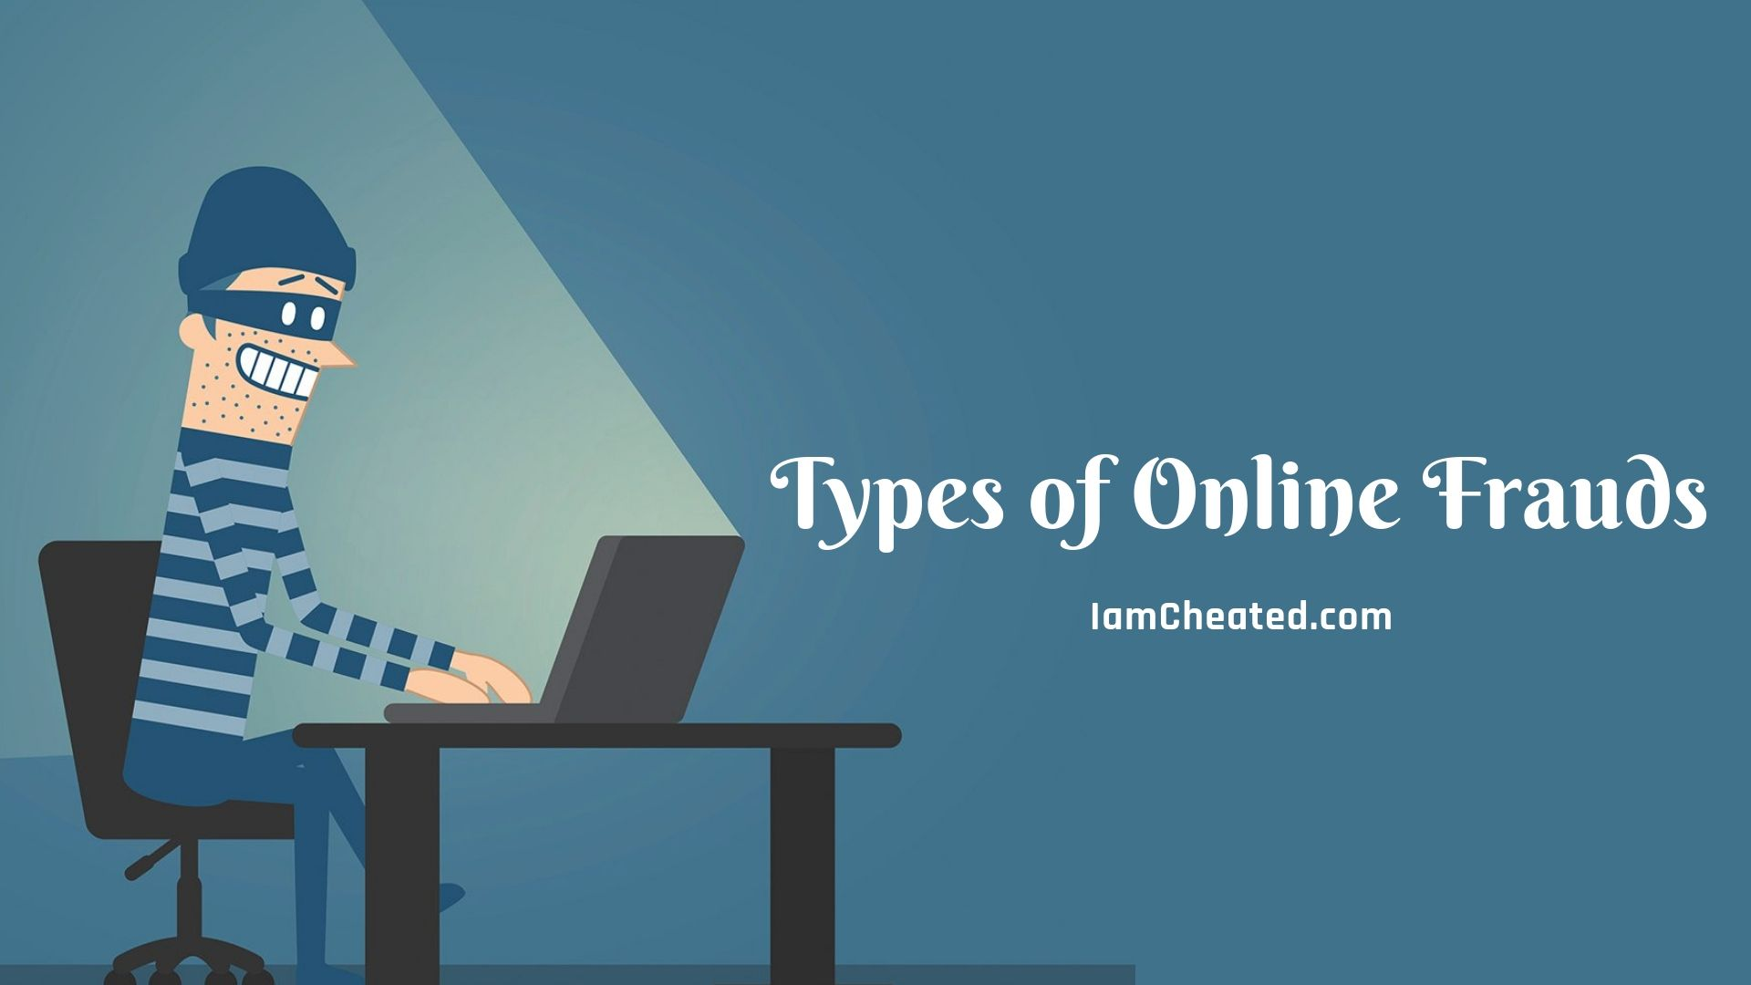

1. Phishing: Fraudsters create fake websites or emails resembling legitimate institutions to obtain sensitive information such as login, credentials, credit card numbers on personal details

2.Identity Theft: Criminals steal personal information to make an authorized transactions or open accounts in the name of the victim.

3. Credit Card Fraud: Criminals steal credit card information to make unauthorized purchases online.

4. Fake Online Stopes: Criminal steal debit cards in disguise of fraudulent websites offer goods or services at attractive prices, but never deliver the Products after payment.

﻿5. Investment Scams: Fraudulent investment schemes promise high returns but are designed to steal money from unsuspecting investors.

Implications of Online Fraud:

•Financial Loss: Victims can suffer significant financial losses from unauthorized transactions & stolen funds.

•Identity Compromise: Identity theft can lead to a host of problems, including damage to credit scores and reputation.

• Emotional Impact: Being a victim of fraud can cause stress, anxiety and a loss of trust in online platforms.

•Trust and Confidence: Online fraud undermines trust and confidence in online platforms, e-commerce websites, and digital transactions, leading to decreased consumer confidence in online services.

•Legal Consequences: Victims of online fraud may face legal consequences such as liability for fraudulent transactions, legal fees associated with recovering losses, and potential damage to their reputation.

•Reputational Damage: Businesses targeted by online fraud may suffer reputational damage, loss of customers, and decreased investor confidence.

•Economic Impact: Online fraud can have broader economic implications, including reduced consumer spending, increased costs for businesses to implement security measures, and potential loss of tax revenue for governments.

Statistical analysis



According to a report by the Bangladesh Telecommunication Regulatory Commission (BTRC), incidents of online fraud have been steadily increasing in Bangladesh over the past few years. The report highlights a concerning trend of cybercriminals targeting unsuspecting individuals and organizations through various fraudulent schemes. Reports indicate that millions of dollars are lost annually due to various forms of online scams, including phishing, identity theft, and financial fraud. These losses not only affect individuals but also have a ripple effect on the economy and consumer confidence. Studies have shown that a significant proportion of online fraud victims in the country fall within the youth demographic, with many lacking awareness and proper safeguards against cyber threats. Reports from financial institutions and cybersecurity experts indicate a rise in fraudulent activities targeting digital payment systems, highlighting the need for enhanced security measures and user education.

Preventive Measures

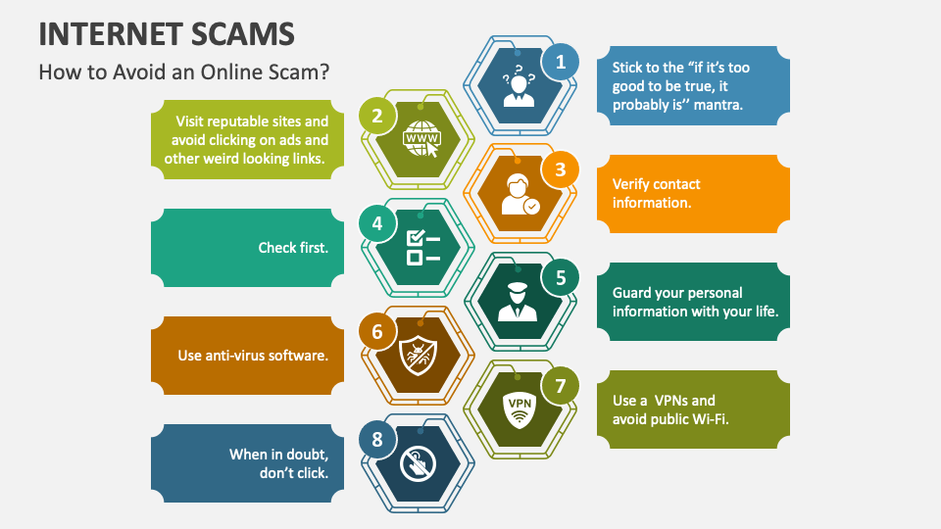

- Strong Passwords: Use unique, complex passwords for each online account and change them regularly. Consider using a password manager to securely store and manage passwords.

- Two-Factor Authentication (2FA): Enable 2FA wherever possible, adding an extra layer of security to your accounts by requiring a second form of verification, such as a code sent to your phone.

- Secure Connections: Only conduct online transactions and share sensitive information on secure websites with HTTPS encryption. Avoid using public Wi-Fi networks for sensitive activities.

- Stay Informed: Keep up to date with the latest scams and fraud tactics. Be cautious of suspicious emails, messages, and phone calls, especially those requesting personal or financial information.

- Verify Sources: Before clicking on links or downloading attachments, verify the sender's authenticity, especially in emails or messages from unknown or unexpected sources.

- Monitor Accounts: Regularly monitor bank statements, credit card transactions, and credit reports for any unauthorized activity. Report any suspicious transactions immediately to your financial institution.

- Use Anti-Malware Software: Install reputable antivirus and anti-malware software on your devices and keep them up to date to protect against malware, phishing attempts, and other online threats.

- Limit Information Sharing: Be cautious about sharing personal information online, especially on social media platforms, and adjust privacy settings to restrict access to sensitive details.

- Educate Yourself: Take the time to educate yourself and your family about common online scams and fraud tactics. Awareness is key to avoiding falling victim to fraudulent schemes.

Online fraud poses a significant threat to the individuals and business in the digital age. By staying vigilant and educating ourselves about common scams and implementing preventive measures, individuals can better protect themselves from falling victim to these schemes. Collaboration between users & law enforcement is crucial in combatting the evolving landscape of online fraud.